Quick Steps On How to Fork a Github Repo

1. Login to Github.
2. Find the repo that you want to fork.
3. Create a new fork using the Fork dropdown.

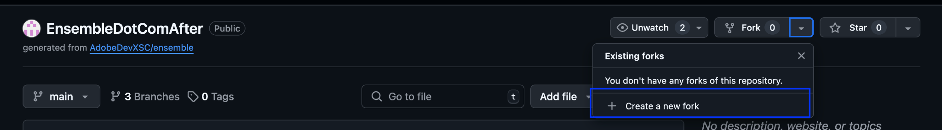

1. Complete the Wizard

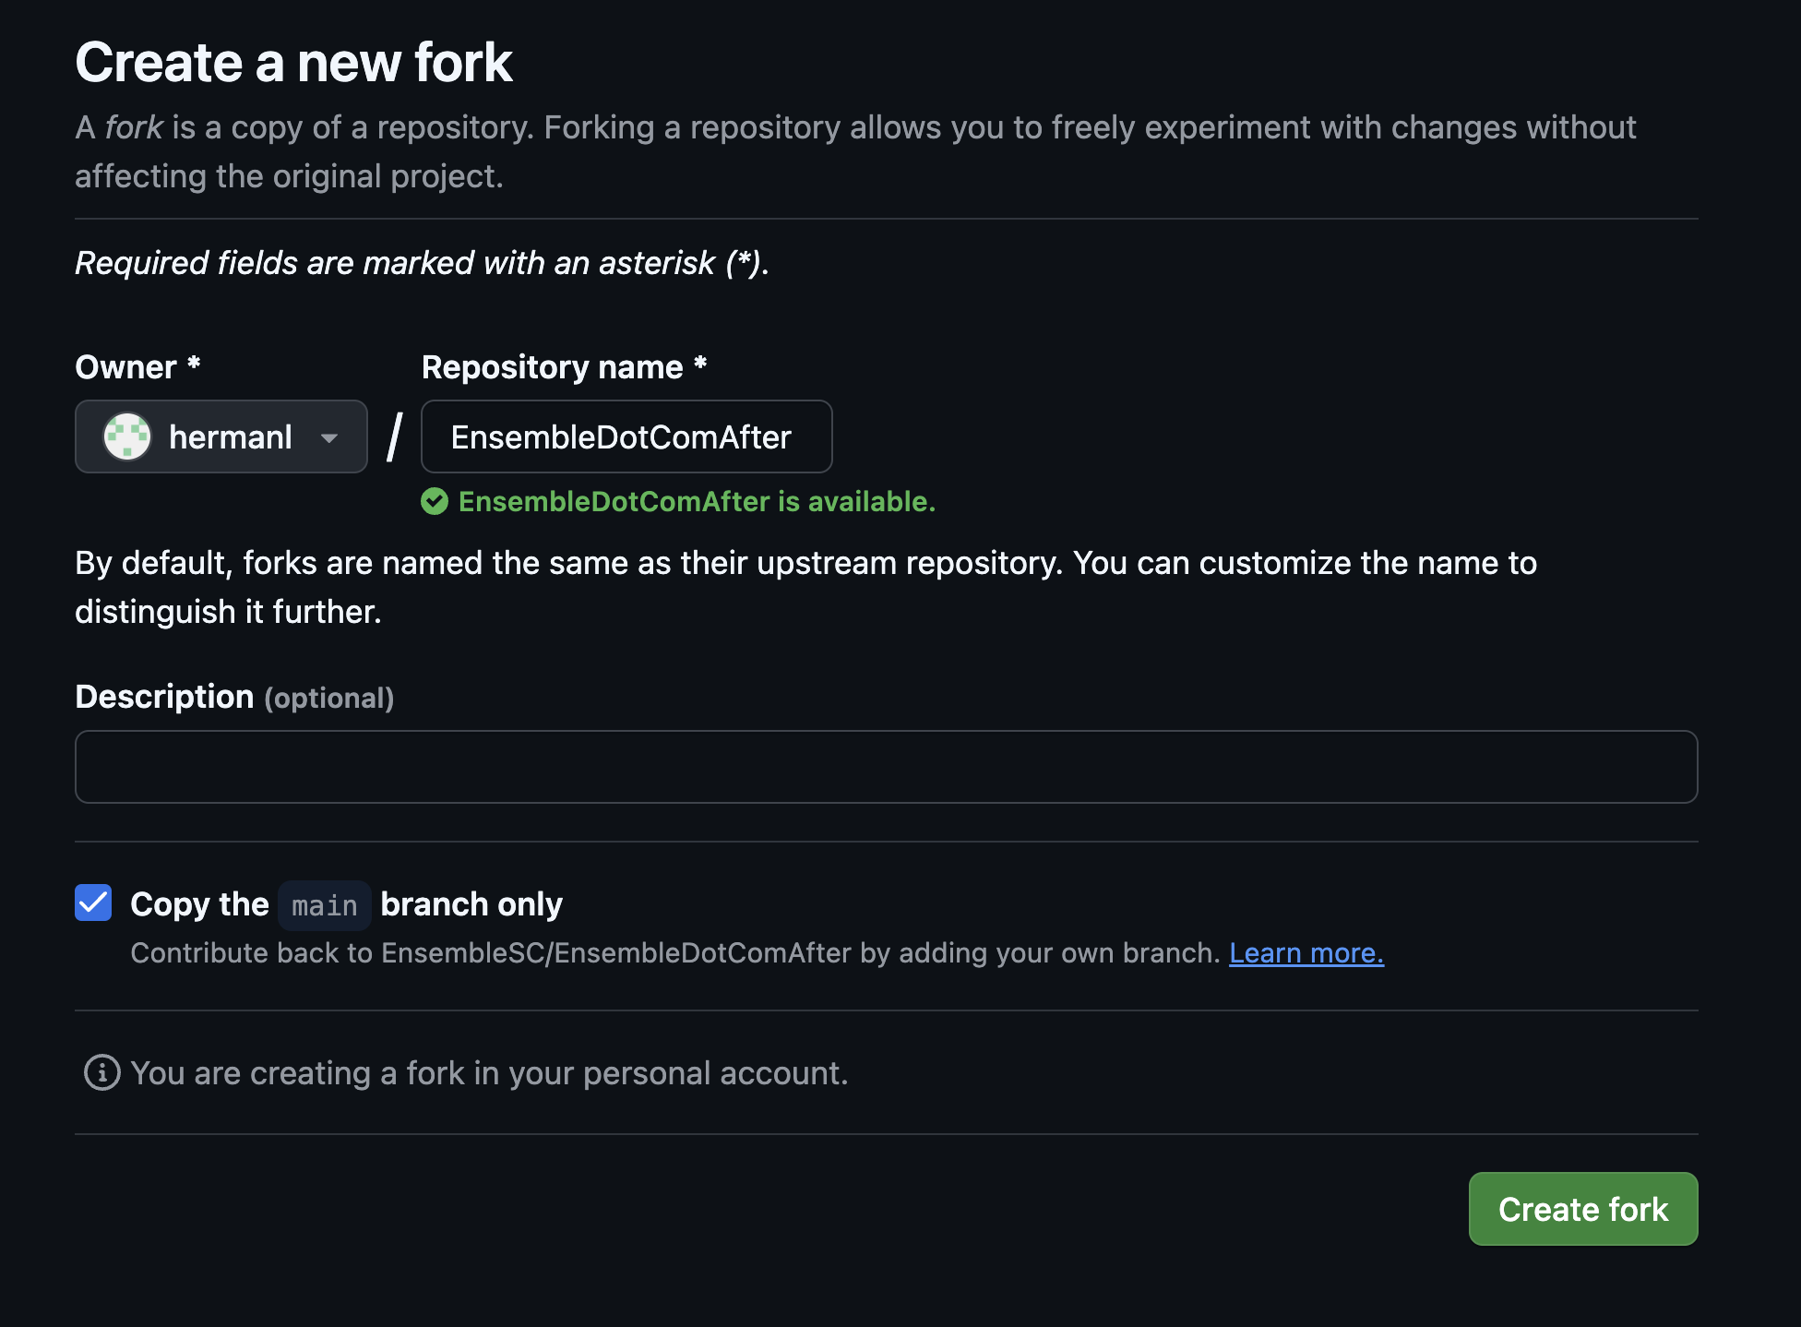

1. Open Visual Studio Code. Open a new window.
2. Open the Source Control menu. 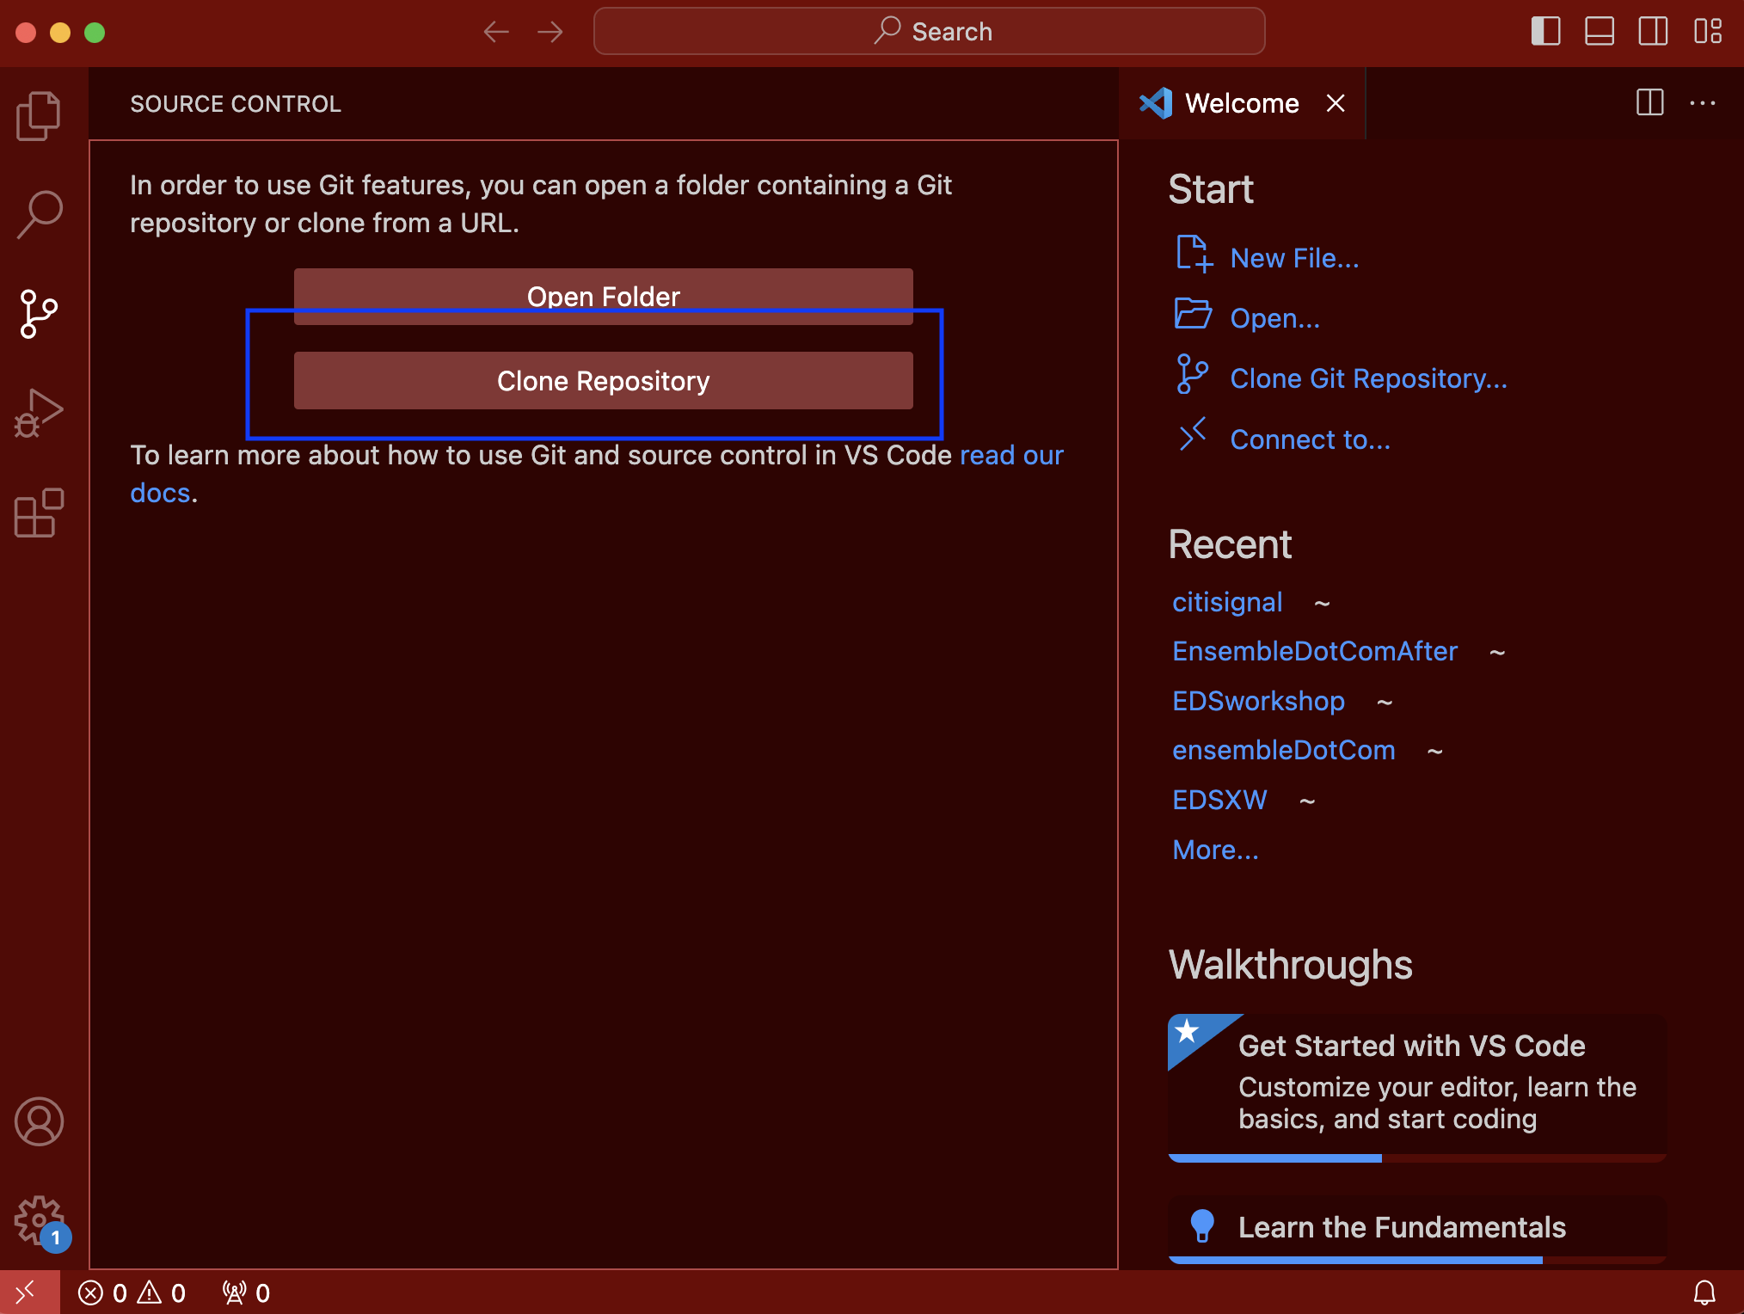
3. Paste the URL of the newly forked repo that you own into the field.

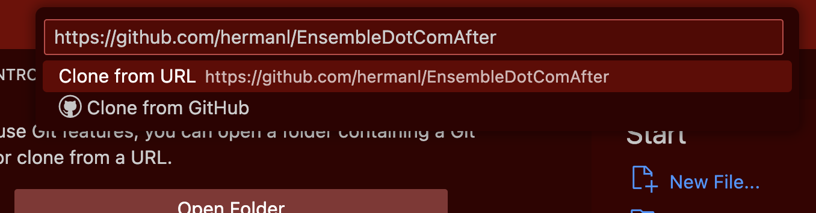

1. Save the repo locally.
2. Done forking. You can make updates now.